AI for Data Hiring
Table of Contents

Introduction – Role of AI in Hiring 2
Step 1. Confirm the Opportunity 2
Step 2. Characterize the Problem and Profile the Data 3
Step 3. Architect and Deploy the Solution 4
Step 4. Evaluate for Business Value 4
Step 5. Scale up the POC 7
References and Resources 8

Introduction – Role of AI in Hiring

Artificial Intelligence (AI) is one of the most important business opportunities for 2020. AI is changing our lives. This technology has the capability that is normally related to human brain.
AI for hiring is a very important category under HR to reduce time consuming activities like manually screening of the resumes.
76% recruiters believe that AI’s impact on recruiting will be somewhat significant. A recent study found that 46 percent of companies struggle with finding and attracting the right candidates for their open positions. AI programs can search online resumes and social profiles to find the best candidates for each job based on specific traits. They can also relay personalized messages to promising candidates and do it in scale that human recruiters could not do alone.
AI is being taught to overcome human biases during sourcing and screening. The key is teaching the program on data that presents as gender-neutral and training it to ignore other identifying information that might trigger biased decisions. An organization may end up with a pool of applicants far more diverse than if the HR team itself had sourced them.
Once your AI program sources and contacts candidates, AI can lead them through the recruiting quickly and efficiently, ensuring the candidate experience goes smoothly. Recruiter chatbots can provide real-time answers to candidate questions, offer quick feedback and suggest next steps. They can provide links to promising job descriptions, clarify company hours and location, and schedule interviews.
AI-powered conversational tools can also give the screening process a boost. AI tools can store essential data on all applicants, saving time and effort when you’re ready to reach out to them again. Companies that use AI tools have reduced their cost per screening by 75 percent.
Using technology to screen talent also saves time and effort for candidates. The tool also brought a measurable improvement in performance, training, new hire retention, and operational outcomes.
AI in HR provides a simple way not only to reach out to possible candidates, but also screen, rank, and shortlist their resumes based on the traits most relevant to your company. Then, once you have a list of people you would like to interview certain AI tools can also help you conduct a later-stage virtual interview before inviting a candidate to come in person.
AI is also improving on boarding procedures by automating repetitive or tedious tasks like conducting background checks, putting together documents about benefits.

Step 1. Confirm the Opportunity

It is very important to sell this idea in the market as this is the most unique feature which is being created to improve the hiring activity in all the colleges. We are also assessing the primary opportunities to benefit the recruitment using AI.
- Consider what other players are doing in recruitment using AI.
- Look for the business problem that can be clearly solved using AI.

- Work in a collaborative environment with a dedicated team of specialist, domain expertise and data scientists who have specialization in Deep Learning and Artificial Intelligence.

Advantages of using this opportunity of AI in recruitment are:
- It improves the quality and objectivity of the recruitment.
- It attracts the right candidates.
- It saves the time and fills the position faster.
- It can also help in eliminating bias in the recruitment process.
- It also improves the candidate experience.
- It improves the quality of hiring.

Step 2. Characterize the Problem and Profile the Data

Problem Definition
There are thousands of applications every year from candidates all over the country seeking admission to colleges and universities and it becomes bottleneck for placement committee to pre-screen them by manually going through each profile. Our approach is one stop AI solution. In order to give fair interview chances to each candidate, we are building up this schematic model. This will outperform the traditional method of placement activity.

Who is facing the problem?

- Placement officer from the college, employers who visit the campus for the placement activity.
- Students are also not aware how much time it takes to shortlist their profiles.
Where is the problem occurring?
Every college in the country is affected by traditional placement activity. It is difficult to figure out each and every college where training is given to the students.
Profiling the data
In this problem, we try to get the placement data from the placement cell of the engineering colleges and then try to use our algorithms to predict the students who are placed in a company. The parameters taken are Name, Email, SSC, HSSC, UG and PG marks, active backlogs, Year of passing, Native place, Highest education, communication, analytical and logical reasoning skills, name of the company in which the student was placed, Location where he/she was placed, Position interviewed for, CTC Received, was placement cell from college providing information about the placement activity, was training provided to the students in order to answer the interview.
Using these parameters, a new dataset was generated.

Step 3. Architect and Deploy the Solution

We now present our proposed application. We first describe the challenges faced in data collection, model training and challenges for finding the students placed during recruitment activity. Then, we present extensive experiments and qualitative analysis to focus onto the insights for deploying such a technology in the real world.

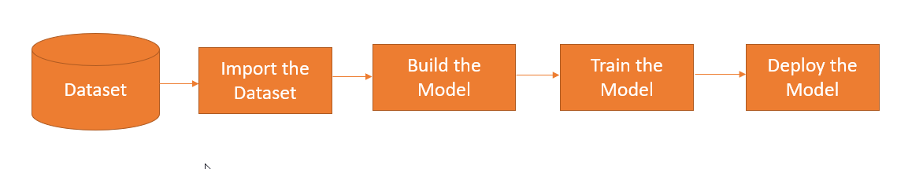

Figure 1: Architecture of the Project

Steps:
- Dataset: Collecting the raw data from the external sources in csv, xlsx format. The dataset is the student information obtained from the college and also from the google form which is used to conduct the survey.

- Import the dataset: Load the dataset in the local IDE.

- Build the model: In this step, import all the necessary packages, clean the data, perform the insights, convert the categorical data into numerical using label encoder and define input variables and target variable.

- Train the model: Use train-test split to define the test size and then use predict function for predicting accuracy, precision, recall and F1 score. Use algorithms like XGBoost, Random Forest Classifier, Gradient Boosting Classifier, Decision Tree Classifier, logistic regression, support vector (SVM), K-Nearest Neighbors(KNN), Artificial Neural Networks(ANN) and Extra Trees Classifier.

- Deploy the model: Once the final model is ready; we deploy the project on the server.

Step 4. Evaluate for Business Value

The following insights were being generated based on the data which was used for analysis.
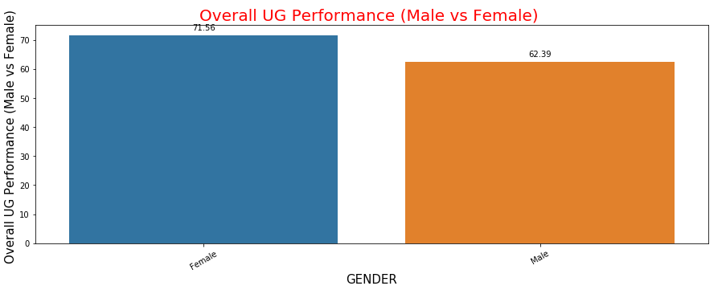
Figure 2: Overall UG performance (Male v/s Female)

In this figure, girls have performed better than boys in under-graduation.

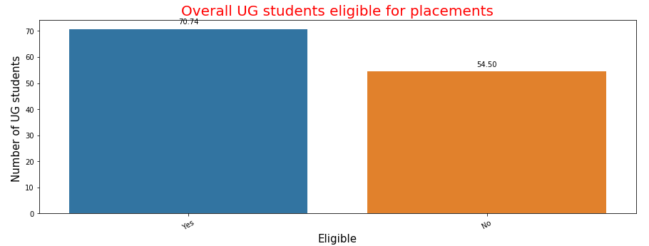

Figure 3: Overall UG students eligible for placements

In this figure, 70 students are eligible for the placement and 54 students are not available for the placements.

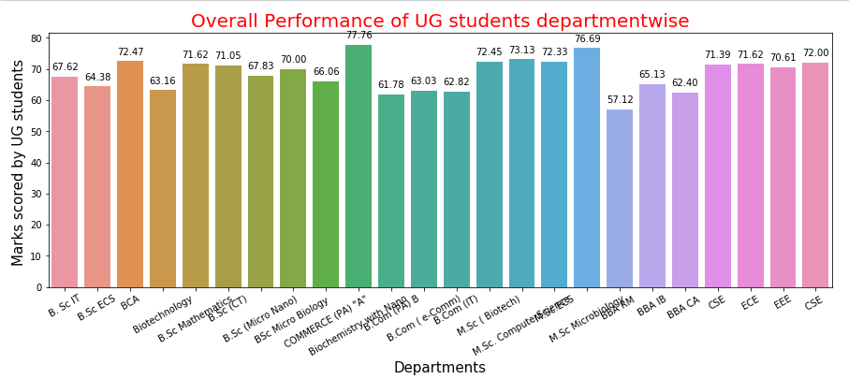

Figure 4: Overall performance of UG students department wise

In this figure, students from commerce department have highest average marks of all the students and microbiology has the lowest average marks of all the students.

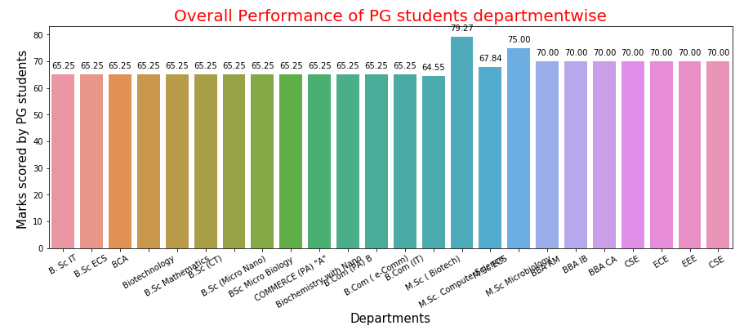
Figure 5: Overall performance of PG students department wise

In this figure, BioTech department has highest average marks of all the students and IT department has the lowest average marks of all the students.

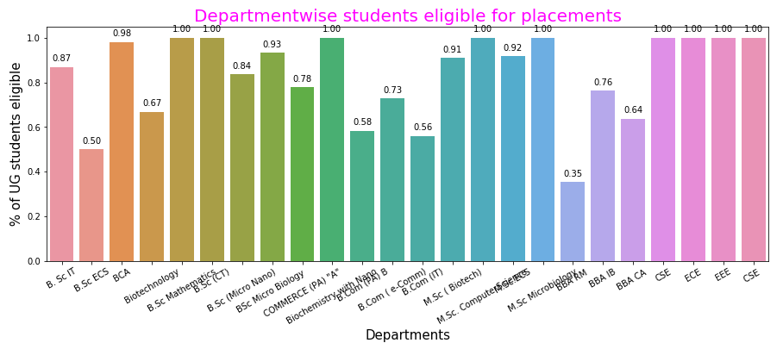

Figure 6: Department wise students eligible for placements

In this figure, the departments in which all the students are eligible for the placement are Biotechnology, Mathematics, Commerce, CSE, ECE, EEE and ECS. In Microbiology department, less number of students is eligible for the placement.
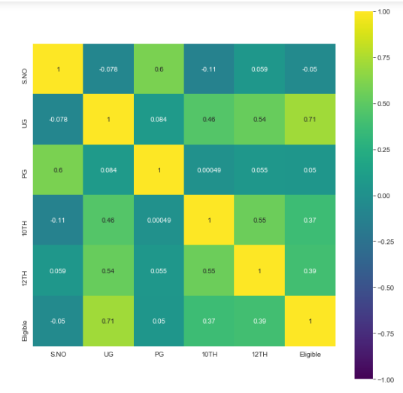
Figure 7: Correlation Matrix representing relationship of all the fields with one another

In this figure, the relation between UG and Eligibility is highly positively correlated.

After running the code, the model gives 85% of the accuracy.

Step 5. Scale up the POC

- Tune and optimize
Currently the data set is very small. So we can add more characteristics in the dataset in future.
The features could be training given, aptitude test marks, coding test marks etc.
We would also handle imbalanced datasets to make the predictions better.

- Additional features
The features like how the candidate is performing in the company, appraisals can also be included to track the performance.

- We can build AI program to smartly analyse candidates’ facial expressions, tone of voice, mannerisms, and word choice.

References and Resources

- AI whitepaper POC https://www.intel.com/content/dam/www/public/us/en/documents/white-papers/ai-poc-whitepaper.pdf
- Student Placement Prediction Using Machine Learning
https://www.irjet.net/archives/V6/i4/IRJET-V6I4997.pdf
- AICTE – CII Survey of Industry Linked Technical Institutes 2018 https://www.aicte-india.org/sites/default/files/AICTE-CII-Survey-Report-2018_1.pdf
- https://www.collegedekho.com/news/campus-placements-management-engineering-students-statistics-15132/
- https://www.peoplestrong.com/india-skills-report-2019-47-engineering-graduates-employable-ap-leads-with-highest-employability-rate/

